|  |  |  |  |
| --- | --- | --- | --- |
| 1 | This is the starting page. The text APPLE will have animation appearing. | 2 | This is the second page. The apple logo will change color, IPHONE 12 PRO MAX image will appear from the outside the box to the top left , lastly the text IPHONE 12 PRO MAX will fade in. |
|  |  |  |  |

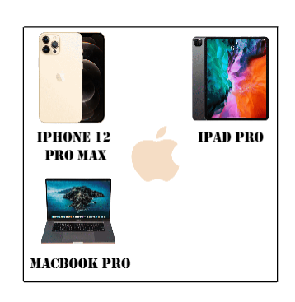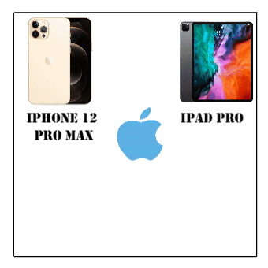3.

This is the second page. The MACBOOK PRO image will appear from the outside the box to the bottom left, lastly the text MACBOOK PRO will fade in.

4.

This is the second page. The IPAD PRO image will appear from the outside the box to the top right, lastly the text IPAD PRO will fade in.

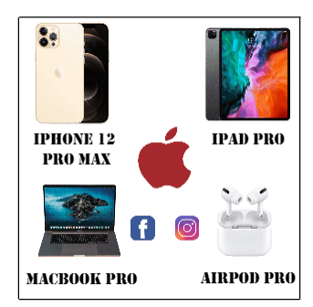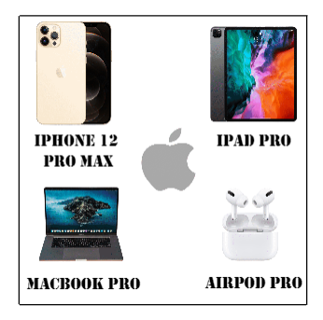5.

This is the second page. The Facebook and Instagram will appear and it will link to Apple Facebook page and Apple Instagram page respectively.

6.

This is the second page. The AIRPOD PRO image will appear from the outside the box to the bottom right, lastly the text AIRPOD PRO will fade in.